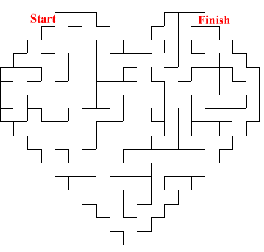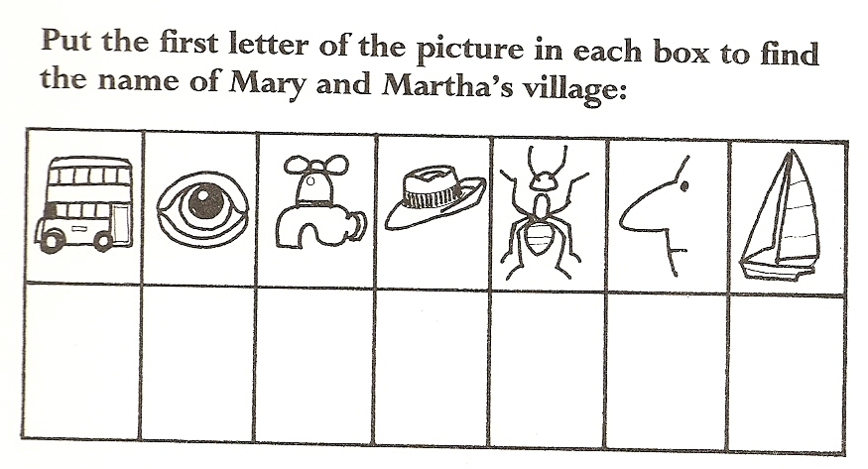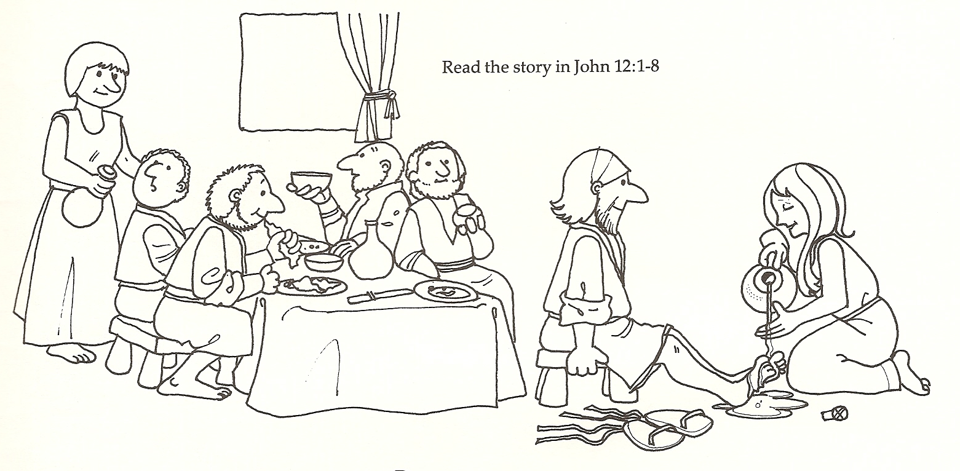 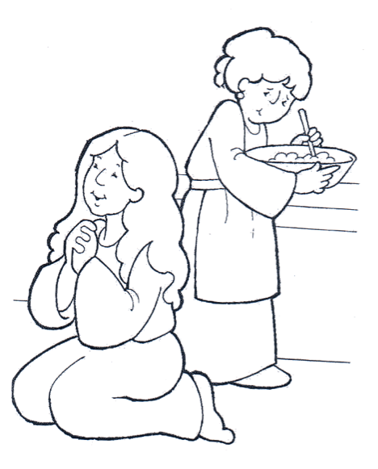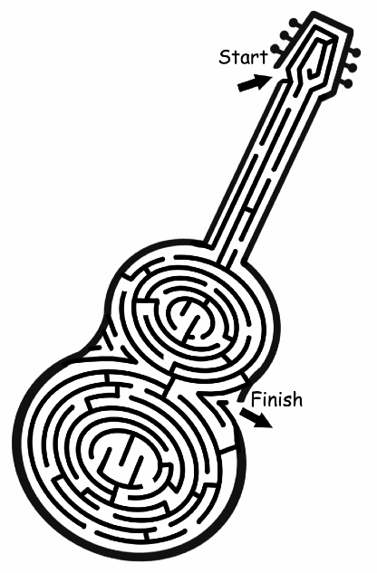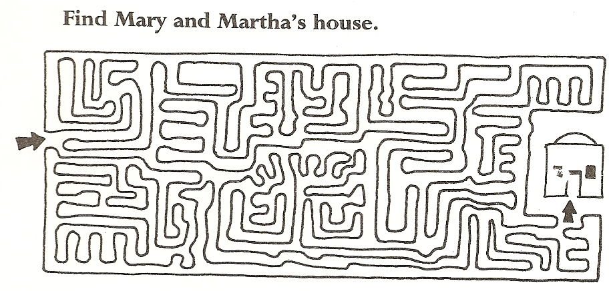 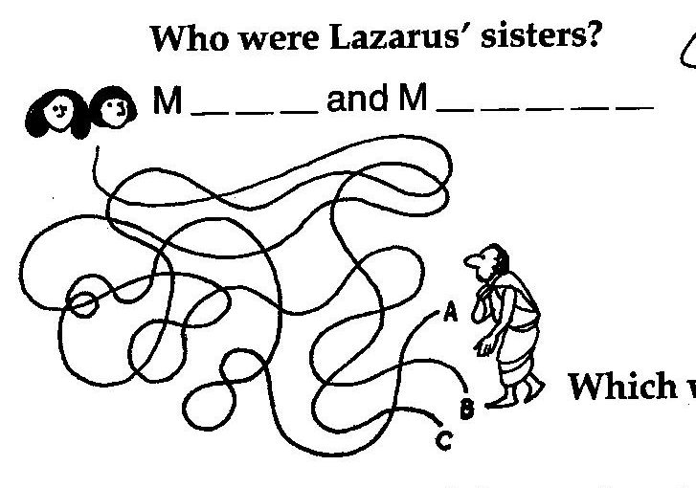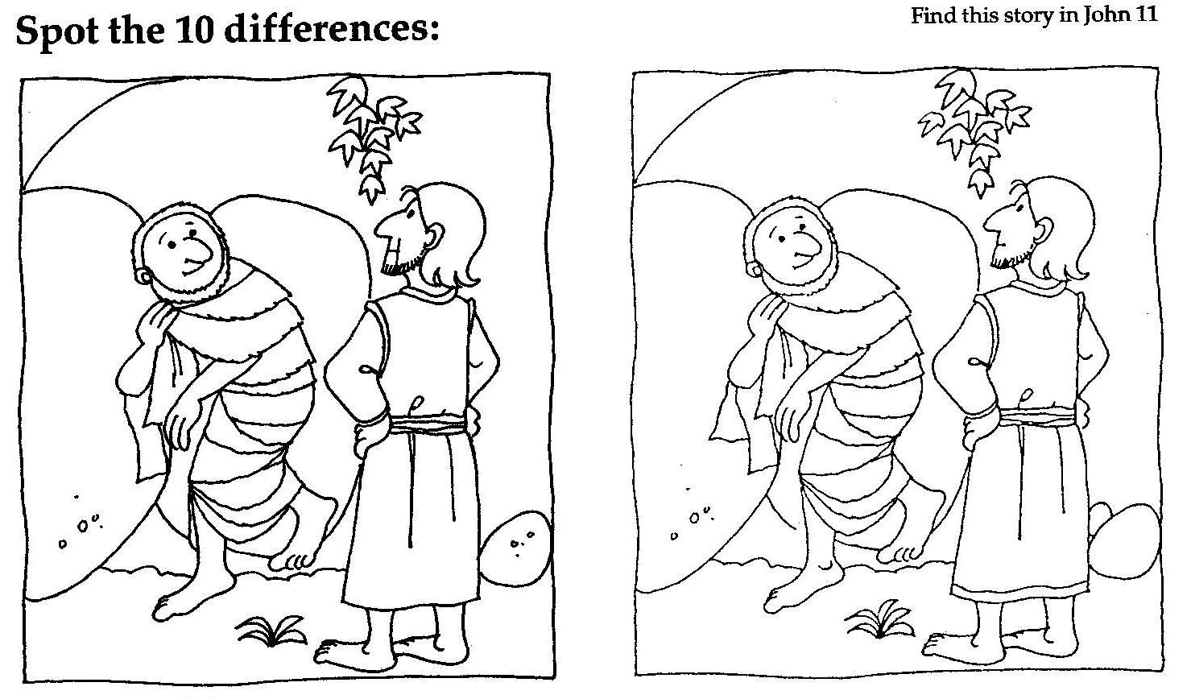

Disciples

Heart

Jesus

Lord

Mary

Martha

Serving

Work

|  |  |  |  |  |  |  |  |  |
| --- | --- | --- | --- | --- | --- | --- | --- | --- |
| H | J | E | S | U | S | L | E | I |
| A | O | G | T | Y | D | P | M | U |
| F | R | N | J | C | H | N | A | P |
| N | M | I | A | G | W | O | R | K |
| L | S | V | H | E | A | R | T | I |
| O | K | R | S | U | B | M | H | E |
| R | G | E | B | W | Y | R | A | M |
| D | I | S | C | I | P | L | E | S |

Dance

Drums

Guitar

Music

Piano

Praise

Sing

Worship

|  |  |  |  |  |  |  |  |
| --- | --- | --- | --- | --- | --- | --- | --- |
| C | I | S | U | M | D | D | E |
| M | G | U | I | T | A | R | S |
| E | N | T | S | P | N | U | I |
| P | I | A | N | O | C | M | A |
| H | S | D | L | G | E | S | R |
| A | W | O | R | S | H | I | P |

P a  Y   h a s

C h o s e n   Q h a T

I s   b e T  e R.

 u k e   S J v O U

|  |  |  |  |  |  |  |  |  |  |  |
| --- | --- | --- | --- | --- | --- | --- | --- | --- | --- | --- |
| a | b | C | e | h | i | k | l | ❐ | n | o |
| a | b | c | e | h | i | k | L | M | n | o |
| R | s | T | u | v | Q | Y | ☺ | S |  | O |
| r | s | t | u | v | w | y | 0 | 1 | 2 | 4 |

Alive

Bethany

Died

Jesus

Lazarus

Martha

Mary

Raise

Sick

Tomb

|  |  |  |  |  |  |  |  |  |  |
| --- | --- | --- | --- | --- | --- | --- | --- | --- | --- |
| J | M | A | R | Y | H | F | O | A | B |
| E | A | D | L | C | I | P | G | L | N |
| S | R | A | I | S | E | D | E | I | D |
| U | T | O | M | B | J | K | M | V | A |
| S | H | E | Y | N | A | H | T | E | B |
| L | A | Z | A | R | U | S | I | C | K |

_ _ _ _ _ _ _, the brother of Mary and Martha, was sick. So the sisters sent word to Jesus, “Lord, the one you love is _ _ _ _.” Now Jesus loved _ _ _ _ _ _ and her sister and Lazarus. So when he heard that Lazarus was sick, he stayed where he was two more days, and then he said to his

_ _ _ _ _ _ _ _ _, “Let us go back to Judea.”

On his arrival, _ _ _ _ _ found that Lazarus had already been in the

_ _ _ _ for four days. When Martha heard that Jesus was coming, she went out to meet him, but Mary stayed at _ _ _ _. “Lord,” Martha said to Jesus, “if you had been here, my _ _ _ _ _ _ _ would not have died. But I know that even now God will give you whatever you _ _ _.” Jesus said to her, “Your brother will rise _ _ _ _ _.”

|  |  |  |  |  |
| --- | --- | --- | --- | --- |
| again | ask | brother | disciples | home |
| Jesus | Lazarus | Martha | sick | tomb |

☺ e      w e  .

J  h n     v □ l

Alive

Compassion

Died

Jesus

Lazarus

Martha

Mary

Raise

Tomb

Wept

|  |  |  |  |  |  |  |  |  |  |  |  |
| --- | --- | --- | --- | --- | --- | --- | --- | --- | --- | --- | --- |
| M | A | R | T | H | A | J | E | S | U | S | T |
| C | Y | P | D | I | E | D | V | O | Y | H | O |
| T | E | S | I | A | R | M | I | T | R | E | M |
| W | S | U | R | A | Z | A | L | D | A | F | B |
| A | B | N | O | I | S | S | A | P | M | O | C |

|  |  |  |  |  |  |  |  |  |  |  |  |  |  |
| --- | --- | --- | --- | --- | --- | --- | --- | --- | --- | --- | --- | --- | --- |
| e | h | J | n | O | I | S |  |  | v | ⬥ | Q | ❐ | ● |
| e | h | J | n | o | p | s | t | u | v | w | 1 | 3 | 5 |