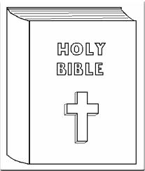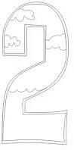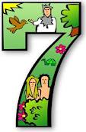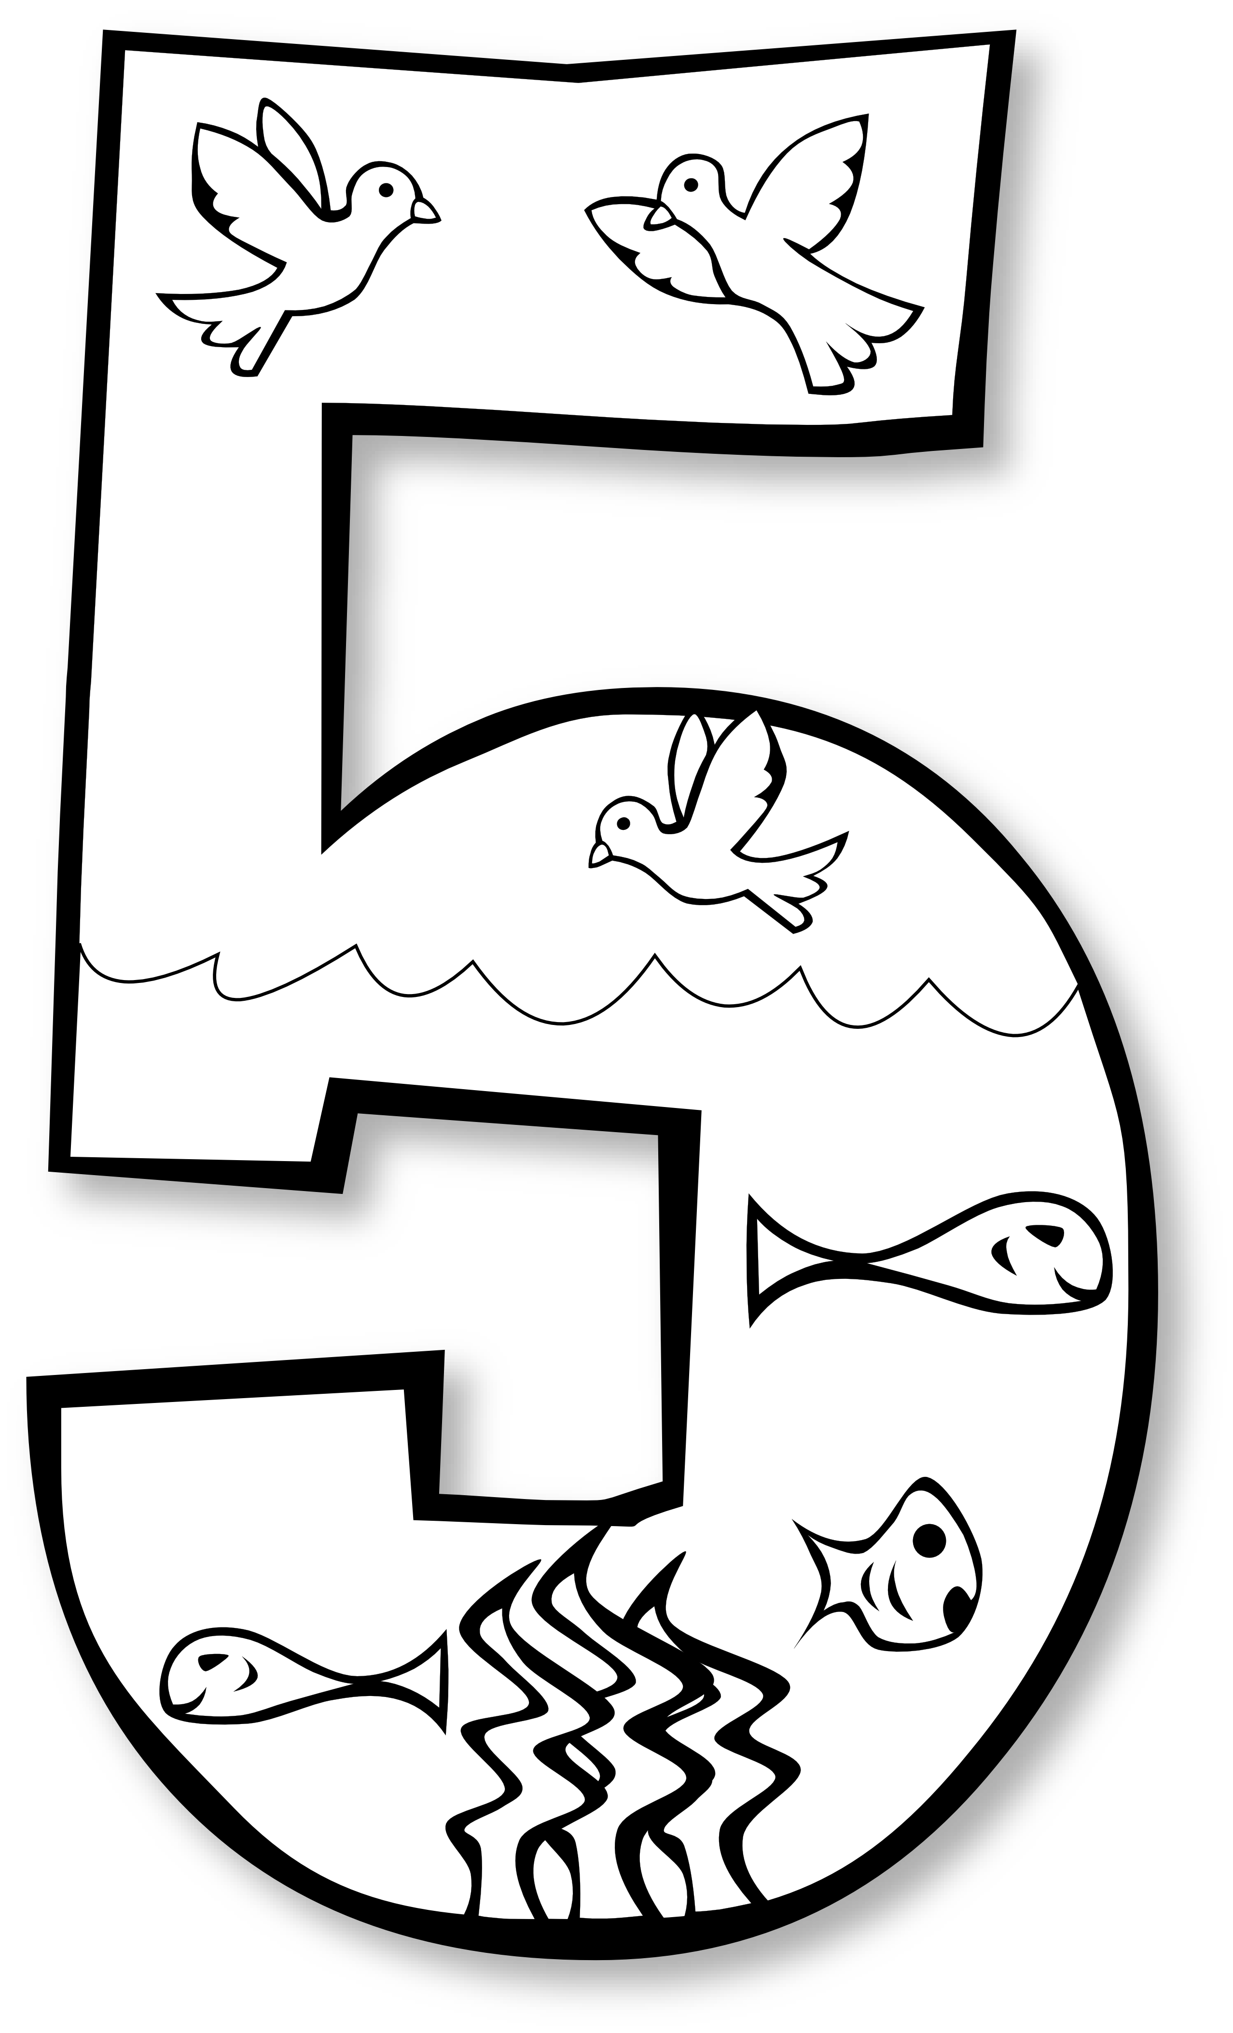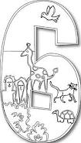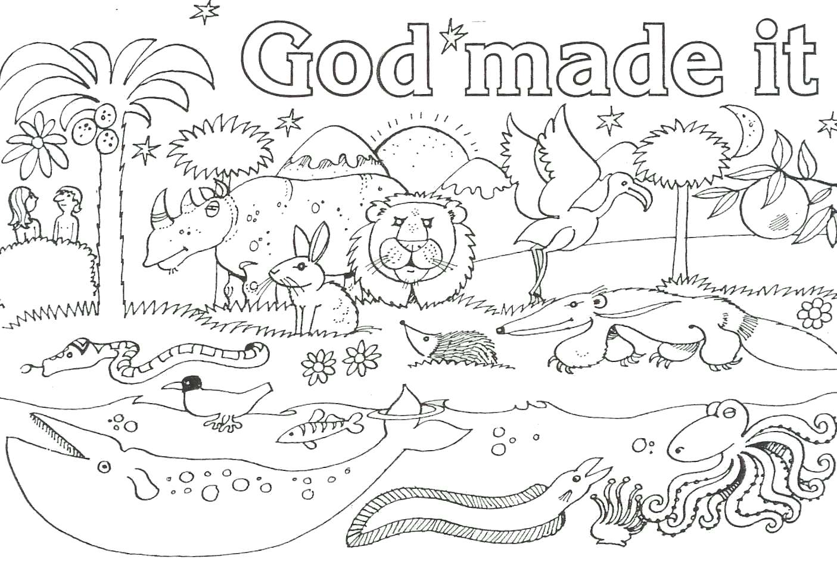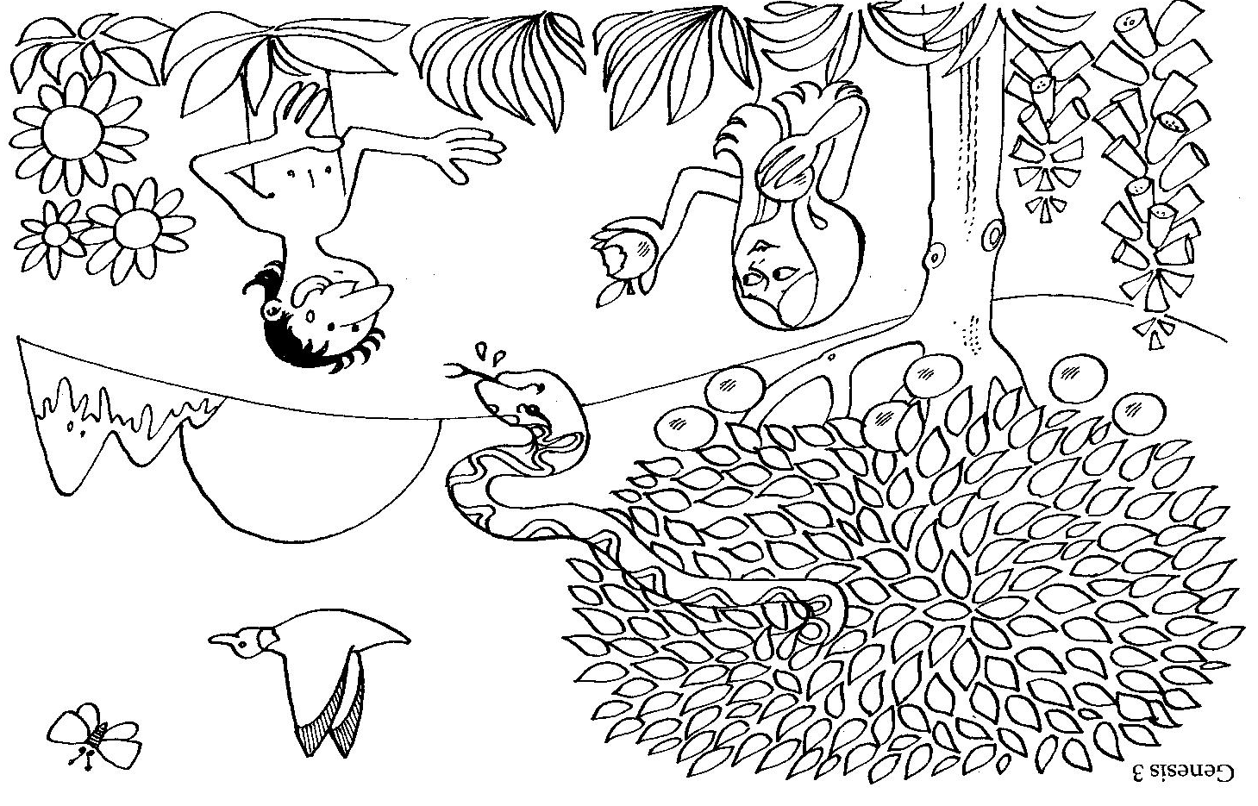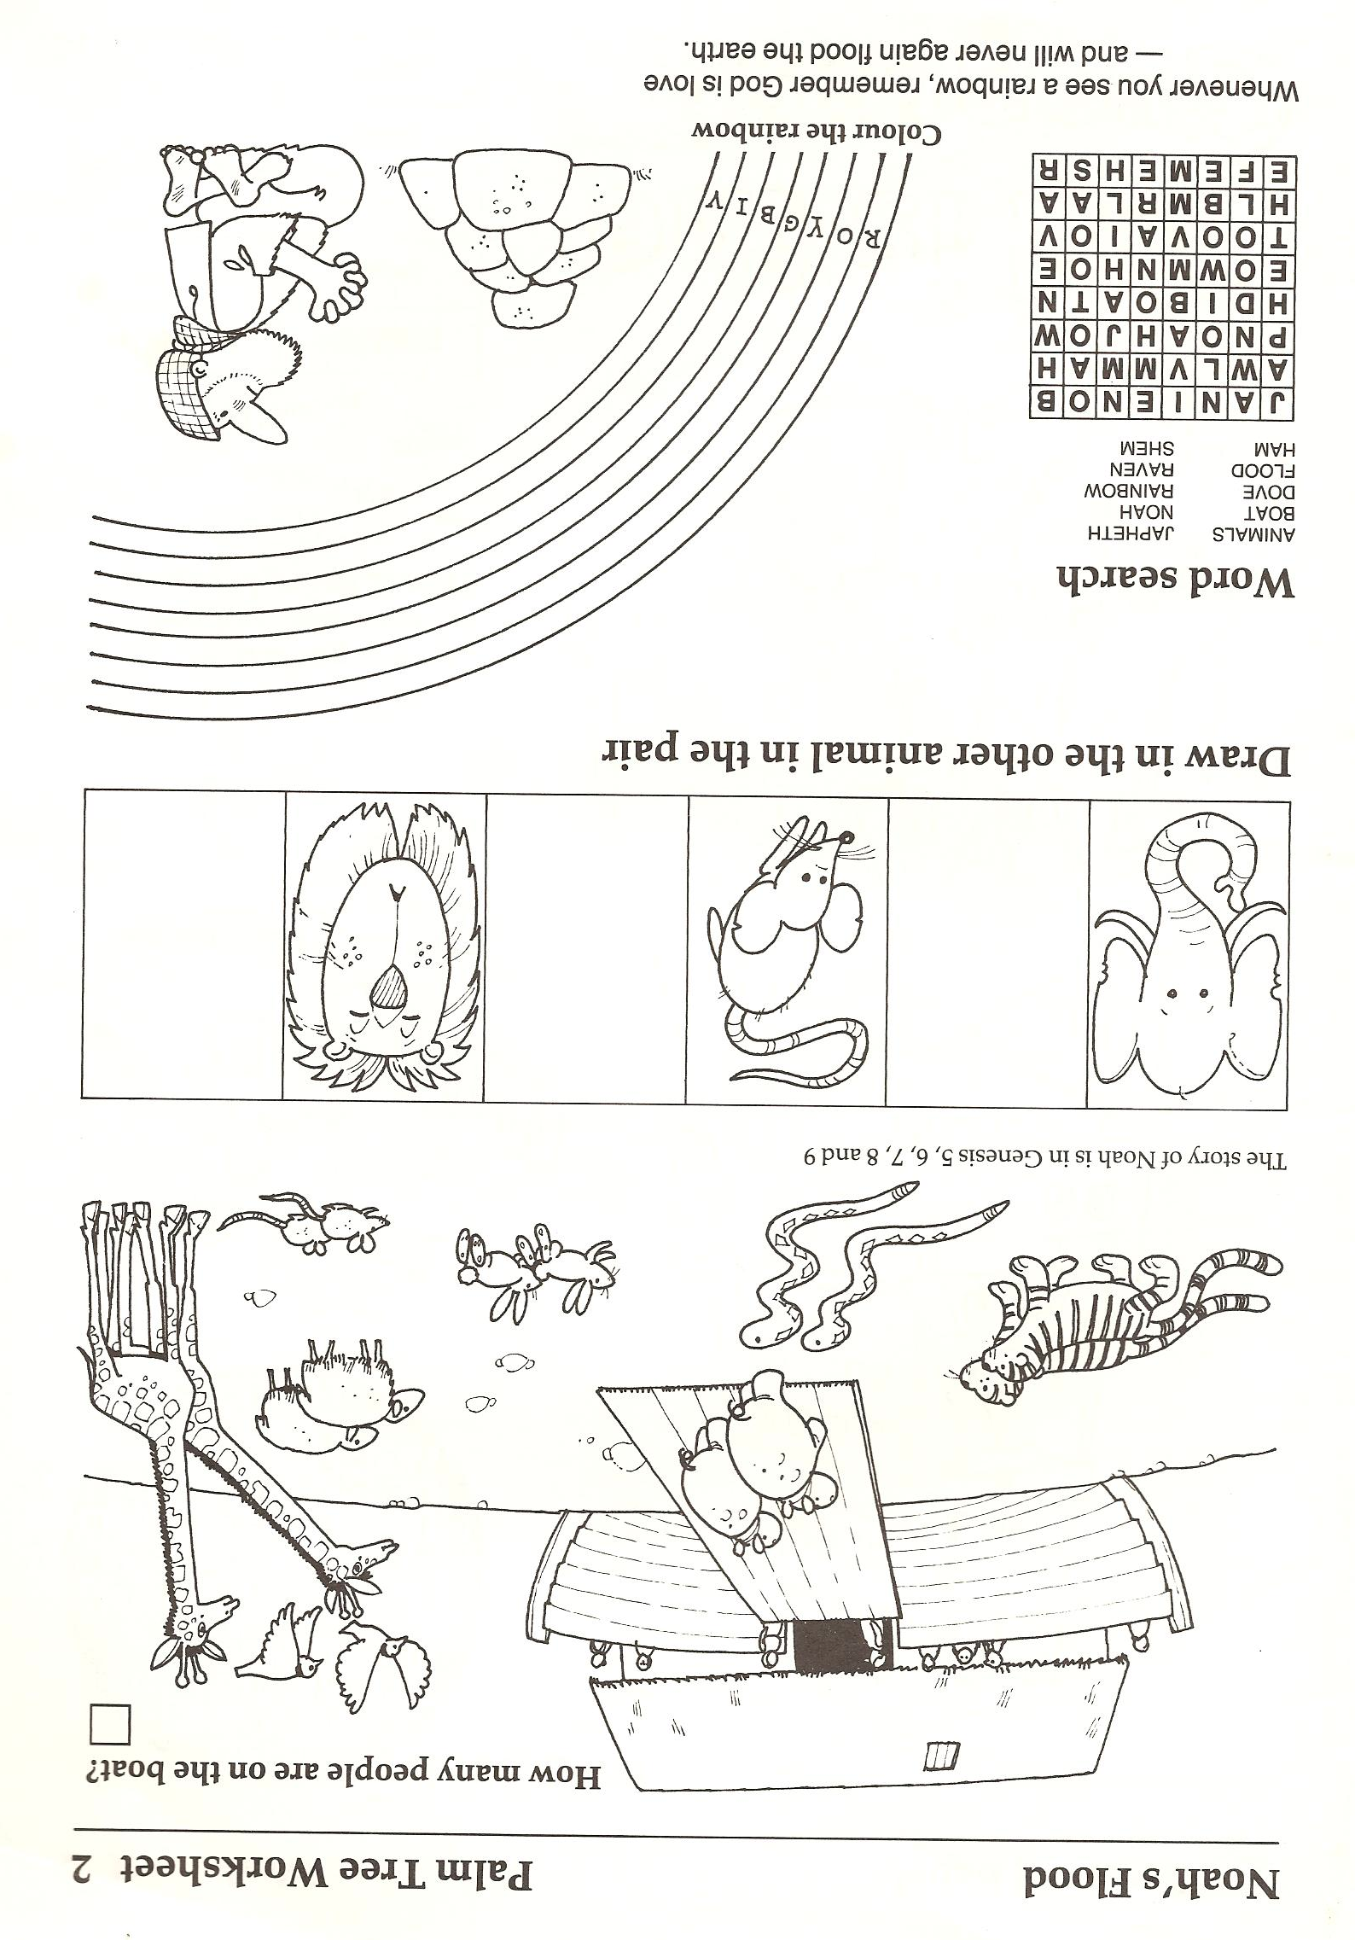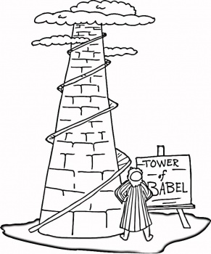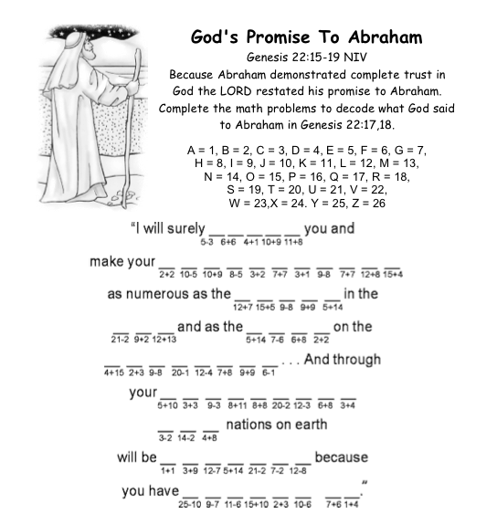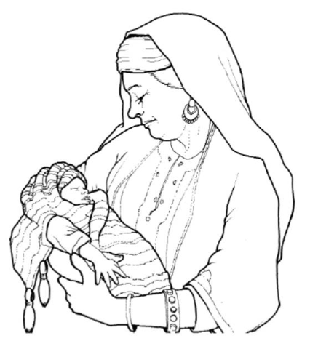 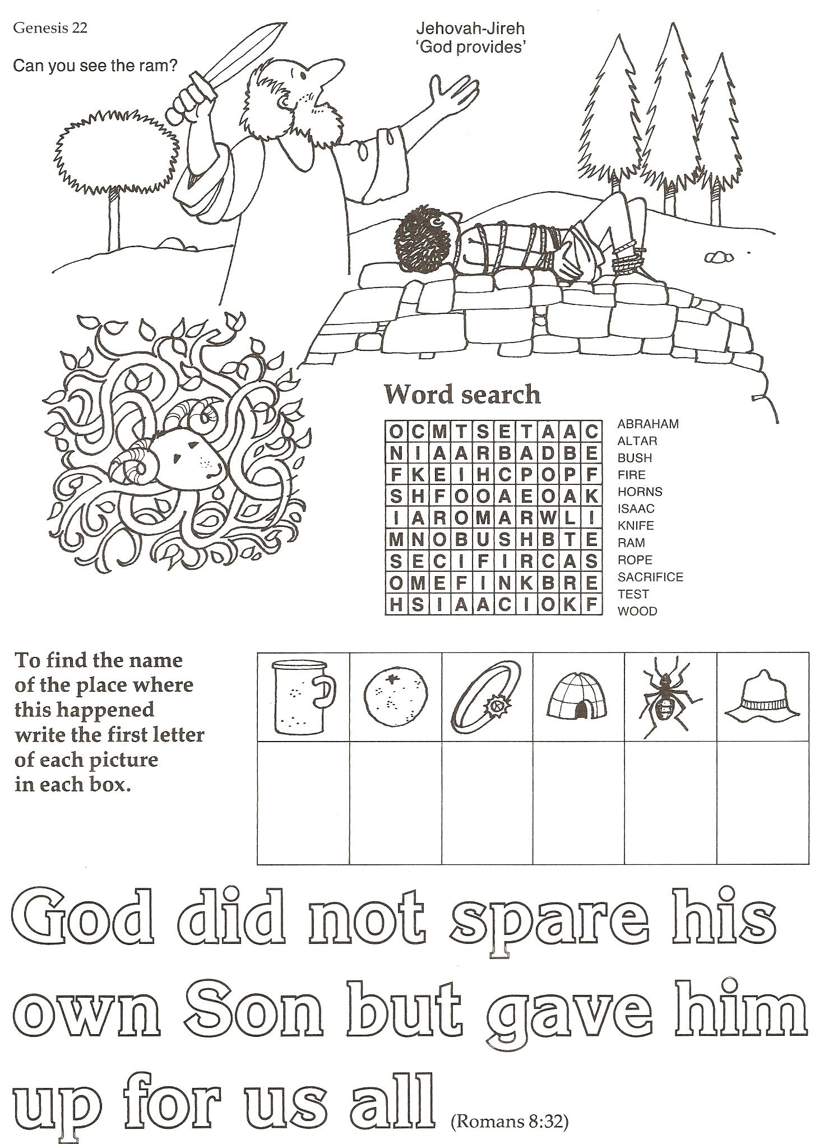 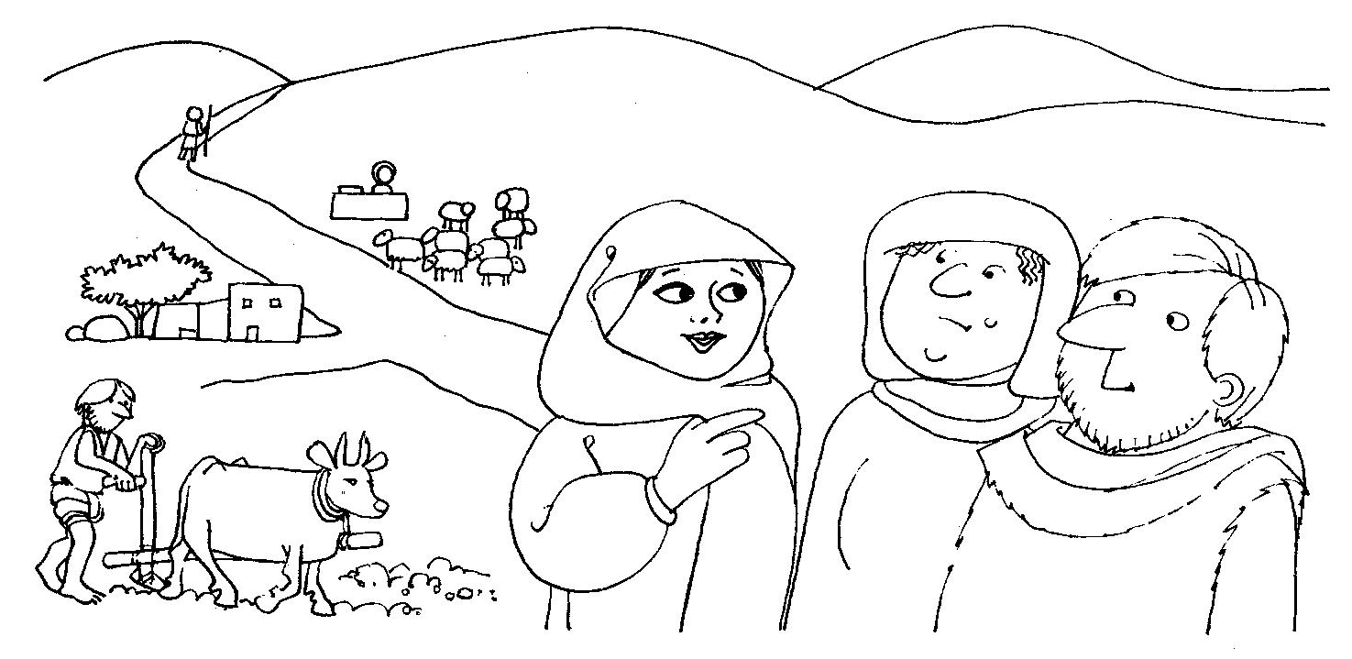

Page 1

Each week we will be looking at a different Bible Story. Put them in your folder in order using the numbers at the top of the page to make your own story bible.

Can you draw a picture of your favourite bible story?

Can you crack the code to find out what the word bible means?

|  |  |  |  |  |  |
| --- | --- | --- | --- | --- | --- |
|  |  |  |  |  |  |
| a | b | i | l | r | y |

Psalm 19 and Hebrews 1

light and dark

sea, sky and space

earth and plants

sun, moon and stars

God rested

land animals, man and woman

sea animals sky animals

Genesis 1 - 2

Page 2



Can you spot the 10 differences?

Adam and Eve lived in the Garden of Eden. God told them they could eat fruit from any tree except for one. Satan wanted to ruin God’s plan so he lied to Eve and told her she should eat the fruit. Eve and Adam both tasted the fruit and then everything went wrong because they had sinned against God. Adam and Eve hid from God but God knew what they had done. They had to leave the Garden of Eden forever.

Page 3

Genesis 3

bird

giraffe

mouse

rabbit

rhino

sheep

snake

tiger

Noah was only good man in the world, everybody else

was bad. God wanted to start again so He told

Noah to build an ark and to take two of

every kind of animal with him. Then

God made the rain come down

until there was a great flood

that covered the world.

Only those in the ark

were safe. When the

waters had gone,

Noah came out of

the ark. God

put a rainbow

in the sky and

promised

never to

flood the

world

again.

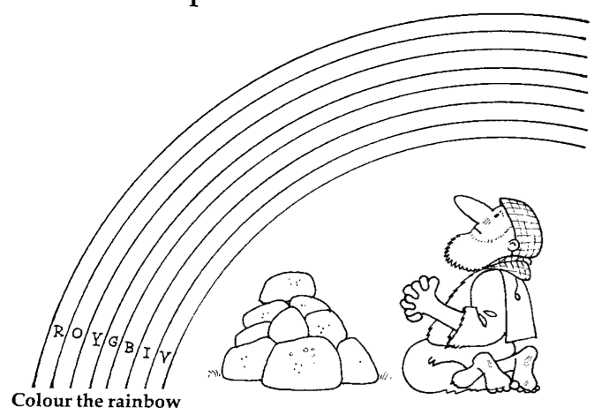

Genesis 6 - 9

Can you find these animals in the wordsearch?

Page 4

|  |  |  |  |  |  |  |  |
| --- | --- | --- | --- | --- | --- | --- | --- |
| t | r | b | s | h | e | e | p |
| i | h | i | n | c | r | d | m |
| g | i | r | a | f | f | e | o |
| e | n | d | k | b | s | p | u |
| r | o | t | e | n | g | a | s |
| t | r | a | b | b | i | t | e |

Can you crack the code by matching the numbers to the letters?

The people wanted to build a gigantic tower

that would reach all the way to heaven. But

God wasn’t pleased with them, He could see

they were trying to live without him. So God

stopped their plans by mixing up all their

languages so they couldn’t understand each

other. It wasn’t easy to work together after

that so they had to stop. God knew that

however hard they tried people would never

get to heaven by themselves so

heaven would have to come down

to them.

|  |  |  |  |  |  |  |  |  |
| --- | --- | --- | --- | --- | --- | --- | --- | --- |
| 1 | 2 | 3 | 4 | 5 | 6 | 7 | 8 | 9 |
| a | b | e | f | l | o | r | t | w |

8 6 9 3 7 6 4 2 1 2 3 5

Genesis 11

Page 5

|  |  |  |  |  |  |  |
| --- | --- | --- | --- | --- | --- | --- |
| i | s | a | a | c | p | g |
| g | h | n | b | i | f | o |
| b | u | e | r | t | m | d |
| s | a | r | a | h | s | i |
| c | r | l | h | y | d | a |
| o | s | t | a | r | t | h |
| p | r | o | m | i | s | e |

Abraham

God

Isaac

Promise

Sarah

Star

|  |  |  |  |  |  |  |  |  |  |  |  |
| --- | --- | --- | --- | --- | --- | --- | --- | --- | --- | --- | --- |
| a | e | f | g | h | l | n | o | r | s | t | u |
| a | e | f | g | h | l | n | o | R | S | t | U |

S o n    o f    l a U g h t e R

What does Isaac mean?

Unscramble the code to find out

God promised Abraham that his family would be more than all the stars in the sky. But Abraham was 99 years old and didn’t even have a child! But God is faithful to his promises and sure enough, his wife Sarah gave him a Son who they called Isaac.

Genesis 12-21

Page 6

God wanted to be sure that Abraham trusted him completely so he asked him to give him his only son. Abraham obeyed God completely and was prepared to sacrifice Isaac. But because Abraham was faithful and obedient, God provided a ram instead.

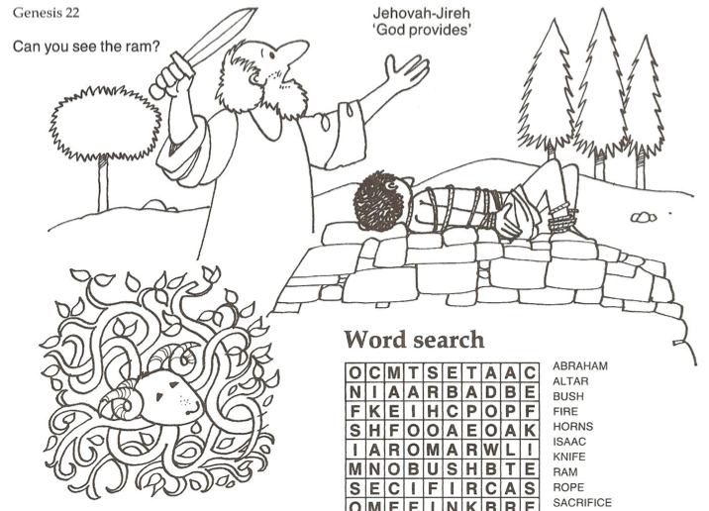

Genesis 22

Page 7

Rachel

Seven

Work

Years

Jacob

Leah

Love

Marry

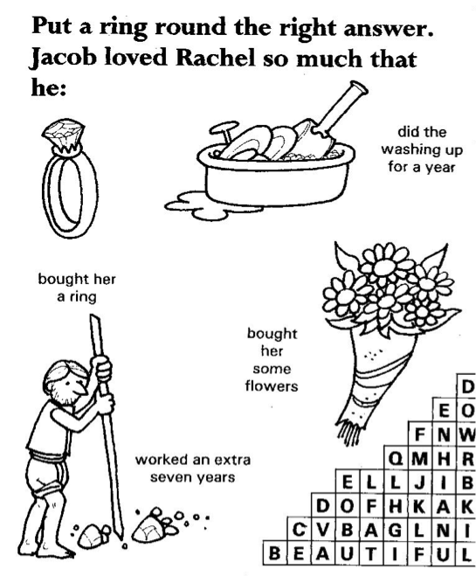

|  |  |  |  |  |  |
| --- | --- | --- | --- | --- | --- |
| w | y | j | r | t | n |
| o | e | a | d | s | u |
| r | a | c | h | e | l |
| k | r | o | m | v | o |
| a | s | b | c | e | v |
| l | e | a | h | n | e |
| m | a | r | r | y | j |

Jacob fell in love with a beautiful girl called Rachel. He agreed to work for her father for 7 years in order to marry her. Rachel’s father tricked him by giving her older sister Leah to him instead. Jacob worked for another 7 years in order to marry Rachel.

Genesis 29-30

Page 8