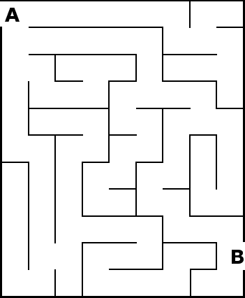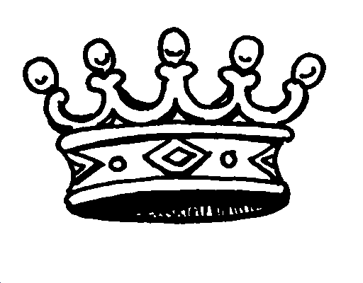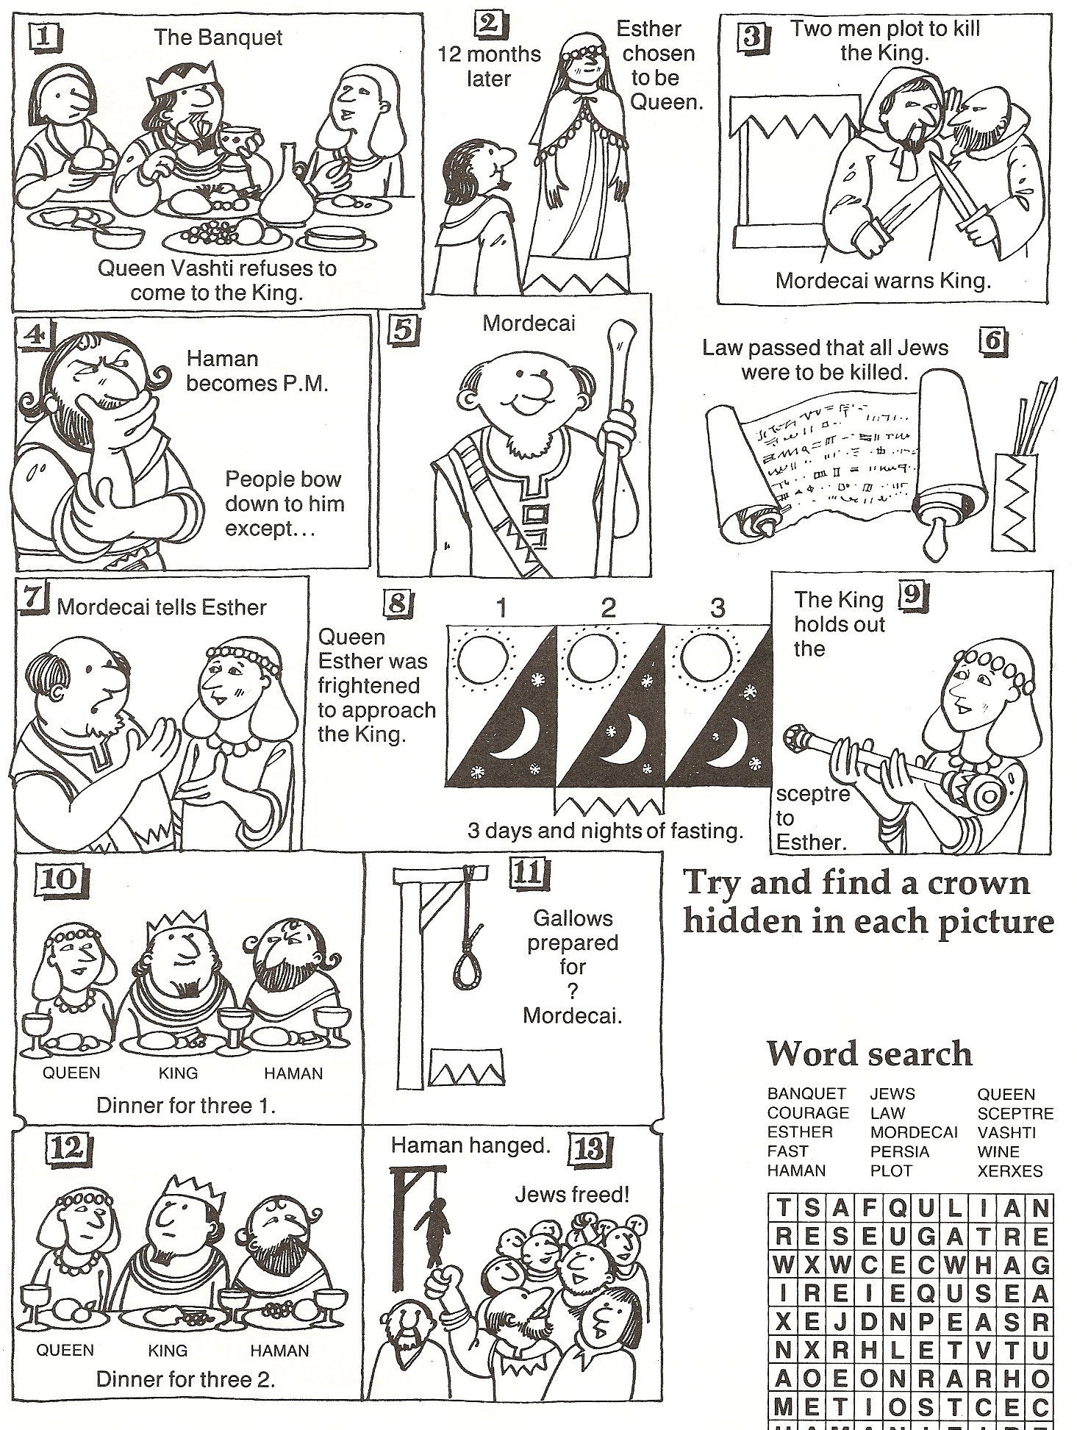

**God loves me,**

**God has chosen me.**

**1 Thessalonians 1v4**

Beautiful

Chosen

Esther

God

King

Queen

Xerxes

Young

|  |  |  |  |  |  |  |  |  |
| --- | --- | --- | --- | --- | --- | --- | --- | --- |
| N | G | H | X | E | R | X | E | S |
| S | C | F | I | D | U | B | L | K |
| L | H | E | K | O | L | T | N | R |
| Y | O | U | N | G | S | F | E | D |
| E | S | T | H | E | R | D | E | A |
| B | E | A | U | T | I | F | U | L |
| G | N | I | K | A | O | C | Q | H |

**Esther**

How many crowns?

Esther

Fast

Haman

Help

Jews

Kill

King

Mordecai

Plot

Pray

Queen

Save

|  |  |  |  |  |  |
| --- | --- | --- | --- | --- | --- |
| T | E | H | M | S | T |
| A | S | W | E | J | O |
| G | R | K | I | L | L |
| I | J | Y | A | R | P |
| E | F | W | C | S | H |
| S | A | V | E | K | Q |
| T | S | R | D | I | U |
| H | T | F | R | N | E |
| E | P | K | O | G | E |
| R | H | A | M | A | N |

**You were**

**chosen**

**for such**

**a time**

**as this.**

**Esther**

**4v14**

**Esther**

**There is a time**

**to be silent and**

**a time to speak.**

**Ecclesiastes 3v7**

**Esther**

Can you unscramble our memory verses and put them in the right order?

**Esther**

**silent**

**chosen**

**has**

**you**

**1 Thessalonians**

**and**

**you.**

**loves**

**1 v 4**

**God**

**time**

**a**

**such**

**for**

**chosen**

**were**

**you**

**Perhaps**

**4 v 14**

**this.**

**as**

**be**

**to**

**time**

**a**

**is**

**There**

**3 v 7**

**Ecclesiastes**

**to**

**time**

**a**

**and**

**speak.**

|  |
| --- |
|  |
|  |
|  |
|  |
|  |
|  |
|  |
|  |
|  |
|  |
|  |
|  |
|  |
|  |
|  |