Week 1 – Armour of God…So Stand Strong

**Scripture**

Ephesians 6v14-18 **So stand strong**, with the belt of truth tied around your waist and the protection of right living on your chest. On your feet wear the Good News of peace to help you stand strong. And also use the shield of faith with which you can stop all the burning arrows of the Evil One. Accept God's salvation as your helmet, and take the sword of the Spirit, which is the word of God. Pray in the Spirit at all times with all kinds of prayers, asking for everything you need. To do this you must always be ready and never give up. Always pray for all God's people.

**Resources Needed**

Bookmarks

Armour

Ball

Relay race resources

**Welcome, Registration and Toilet Time**

**Worship**

Suggested Song – I’m in the Lord’s Army (Unknown)

**Memory Verse**

Be strong and courageous. Joshua 1v6

**Object Lesson - Armour**

God wants us to wear the whole Armour of God to protect us and help us in the battle against the devil.

**Bible Story**

Joshua 6 - Victory at Jericho

God chose Joshua to lead his army. He led them around Jericho and gave them the victory.

**Prayer Time**

Prayer Ball – Pray for the person you throw the ball to that they will be strong and courageous.

**Game**

Relay Race

**Activity**

Bookmark of soldier ‘Be Bold and Courageous’

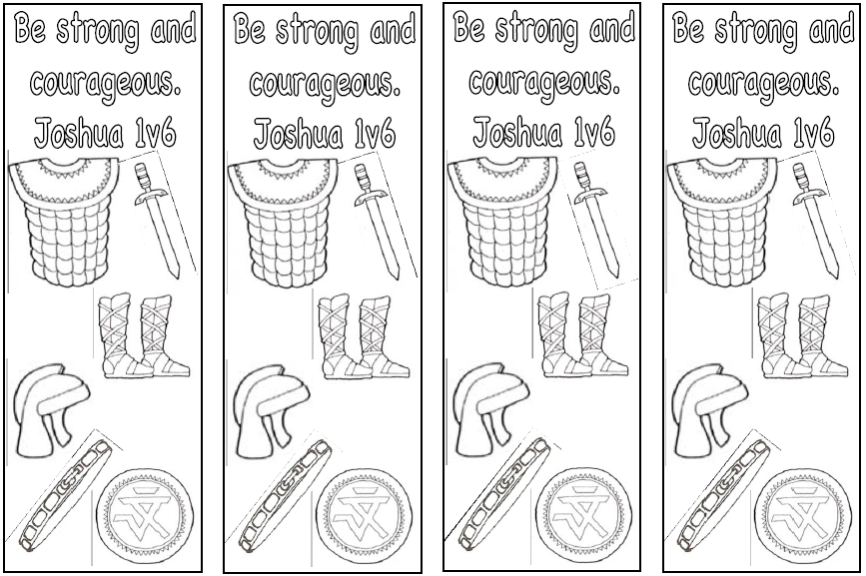

Week 2 – Armour of God…Belt of Truth

**Scripture**

Ephesians 6v14-18 So stand strong, **with the belt of truth tied around your waist** and the protection of right living on your chest. On your feet wear the Good News of peace to help you stand strong. And also use the shield of faith with which you can stop all the burning arrows of the Evil One. Accept God's salvation as your helmet, and take the sword of the Spirit, which is the word of God. Pray in the Spirit at all times with all kinds of prayers, asking for everything you need. To do this you must always be ready and never give up. Always pray for all God's people.

**Resources Needed**

Wide cotton Ribbon

Fabric or Permanent Marker Pens

Balls

Umbrella

**Welcome, Registration and Toilet Time**

**Worship**

Suggested Song – You make me brave (Bethel)

**Memory Verse**

John 8v32 - You will know the truth and the truth will set you free.

**Object Lesson - Belt**

A good soldier needs a belt that his sword can hang on and gives him freedom to move around. We need to wear truth as our belt. God’s truth keeps us free from the devils lies.

**Bible Story**

Split the children into small groups and get them to create a drama about telling the truth, they can act them out to each other.

**Prayer Time**

Circle time - Have you ever told lies? Pray and ask God to help you know the truth.

**Game**

Split the children into four teams and give each team balls of a different colour, stand the children equally far apart from an upturned umbrella and see which team can throw the most balls into the umbrella.

**Activity**

Belt of Truth – Get some wide cotton ribbon and get the children to decorate or write the memory verse on it using fabric or permanent marker pens and tie it around their waist as a belt.

Week 3 – Armour of God…Breastplate of Righteousness

**Scripture**

Ephesians 6v14-18 So stand strong, with the belt of truth tied around your waist **and the protection of right living on your chest**. On your feet wear the Good News of peace to help you stand strong. And also use the shield of faith with which you can stop all the burning arrows of the Evil One. Accept God's salvation as your helmet, and take the sword of the Spirit, which is the word of God. Pray in the Spirit at all times with all kinds of prayers, asking for everything you need. To do this you must always be ready and never give up. Always pray for all God's people.

**Resources Needed**

Picture of Bullet Proof Jacket

Jenga

Eggs and Spoons

Foam Hearts and things to decorate.

**Welcome, Registration and Toilet Time**

**Worship**

Suggested Song – Wonderful Lord (Doug Horley)

**Memory Verse**

Guard your heart. Proverbs 4v23

**Object Lesson - picture of a bullet proof jacket as a modern example**

A breastplate protects us from hurtful words from others. It protects our hearts from accusations from others. Righteousness is right or good living, by living for Jesus we are an example for him.

**Bible Story - Noah**

Noah was an example of a righteous person, he was a good example (Genesis 6v9, Hebrews 11v7)

**Prayer Time**

Jenga – say something good or give a word of encourage to someone else in the group.

**Game**

Egg and Spoon race

**Activity**

Heart Activity – Cut out a heart shape for each child from funky foam and each child can decorate using pens, gems, stickers etc.

Week 4 – Armour of God…Shoes of Readiness

**Scripture**

Ephesians 6v14-18 So stand strong, with the belt of truth tied around your waist and the protection of right living on your chest. **On your feet wear the Good News of peace to help you stand strong**. And also use the shield of faith with which you can stop all the burning arrows of the Evil One. Accept God's salvation as your helmet, and take the sword of the Spirit, which is the word of God. Pray in the Spirit at all times with all kinds of prayers, asking for everything you need. To do this you must always be ready and never give up. Always pray for all God's people.

**Resources Needed**

Shoes

Paint

Tray for paint

Large pieces of paper

Plain Box or box covered in white or brown paper.

**Welcome, Registration and Toilet Time**

**Worship**

Suggested Song – Tell the World (Hillsong)

**Memory Verse**

Go into all the world and preach the good news. Mark 16v15

**Object Lesson - Shoes**

Shoes protect our feet and show we’re ready to go out walking. Wearing shoes reminds us that we need to be always ready to tell others the Good News about Jesus.

**Bible Story**

Peter – preaching the good news.

**Prayer Time**

Prayer Box – For our friend’s – write our friend’s names on a box and pass around picking a name to pray for.

**Game**

Fishes swim

**Activity**

Foot printing – either on individual pieces of paper to take home or cover a section of the floor in paper and the children can all walk around making footprints on the paper.

Week 5 – Armour of God…Shield of Faith

**Scripture**

Ephesians 6v14-18 So stand strong, with the belt of truth tied around your waist and the protection of right living on your chest. On your feet wear the Good News of peace to help you stand strong. **And also use the shield of faith with which you can stop all the burning arrows of the Evil One.** Accept God's salvation as your helmet, and take the sword of the Spirit, which is the word of God. Pray in the Spirit at all times with all kinds of prayers, asking for everything you need. To do this you must always be ready and never give up. Always pray for all God's people.

**Resources Needed**

Shield templates

Paper for collage

Glue and Scissors

Pencils and Paper

Pairs cards

**Welcome, Registration and Toilet Time**

**Worship**

Suggested Song – Wonderful Lord (Doug Horley)

**Memory Verse**

The Lord protects those who are faithful. Psalm 31v23

**Object Lesson - Shield**

A shield protects soldiers from arrows. In battles these were wet so that they can extinguish flaming arrows. When we have a shield made of faith in Jesus, we can stop the arrows of temptation.

**Bible Story**

Jesus’ Temptation – there is a good film clip of this on the Miracle Maker DVD.

Draw out from the children how Jesus used his shield of faith to protect him from.

**Prayer Time**

Drawing prayers – drawing things we might be tempted about and asking God to help us to wear the shield of faith.

**Game**

Make some Pairs cards with different shields and play pairs with the children either all together or in small groups.

**Activity**

Shield collage – decorate a shield using different coloured pieces of paper.

Week 6 – Armour of God…Helmet of Salvation

**Scripture**

Ephesians 6v14-18 So stand strong, with the belt of truth tied around your waist and the protection of right living on your chest. On your feet wear the Good News of peace to help you stand strong. And also use the shield of faith with which you can stop all the burning arrows of the Evil One. **Accept God's salvation as your helmet**, and take the sword of the Spirit, which is the word of God. Pray in the Spirit at all times with all kinds of prayers, asking for everything you need. To do this you must always be ready and never give up. Always pray for all God's people.

**Resources Needed**

Cycle Helmet

Newspaper

Ball

Paper

**Welcome, Registration and Toilet Time**

**Worship**

Suggested Song – Jesus came to save (Village Church)

**Memory Verse**

Salvation comes from the Lord. Psalm 37v39

**Object Lesson – Cycle Helmet**

Helmets protect our heads and minds, firefighters, motorcyclists and construction workers all wear helmets to protect their heads. The helmet of salvation reminds us of God’s forgiveness of our past sins and strength to have victory over sin today and tomorrow.

**Bible Story**

Jesus came to save us

(Isaiah 59v12-20 (v17) and John 3v16)

**Prayer Time**

Write down/draw something we need God’s forgiveness for and then throw it in the bin to show we are forgiven.

**Game**

Ball game

**Activity**

Competition to create a Helmet out of newspaper.

Week 7 – Armour of God…Sword of the Spirit

**Scripture**

Ephesians 6v14-18 So stand strong, with the belt of truth tied around your waist and the protection of right living on your chest. On your feet wear the Good News of peace to help you stand strong. And also use the shield of faith with which you can stop all the burning arrows of the Evil One. Accept God's salvation as your helmet, and **take the sword of the Spirit, which is the word of God**. Pray in the Spirit at all times with all kinds of prayers, asking for everything you need. To do this you must always be ready and never give up. Always pray for all God's people.

**Resources Needed**

Bible

Armour of God printed in different pieces and hidden around the room.

Sword shaped card

Foil

**Welcome, Registration and Toilet Time**

**Worship**

Suggested Song – I will fight the fight (Phil Rogers Thank You Music)

**Memory Verse**

God’s word is sharper than a double-edged sword. Hebrews 4v12

**Object Lesson – Bible**

God’s word is a sword for us and with God’s sword we don’t need to be afraid because God will give us the victory. We need to obey God’s word and know it so that we can fight the devil.

**Bible Story**

Gideon – Judges 7

The Lord was with Gideon and gave him the victory – not because of his strength but because of God.

**Prayer Time**

What are we afraid of? Write/draw on a large sheet of paper.

**Game**

Treasure Hunt each child to find own set of ‘Armour of God’

**Activity**

Cut out of thick card a sword and cover the sword in foil. The children could write the memory verse on the foil in permanent marker pen.

Week 8 – Armour of God…Prayer

**Scripture**

Ephesians 6v14-18 So stand strong, with the belt of truth tied around your waist and the protection of right living on your chest. On your feet wear the Good News of peace to help you stand strong. And also use the shield of faith with which you can stop all the burning arrows of the Evil One. Accept God's salvation as your helmet, and take the sword of the Spirit, which is the word of God. **Pray in the Spirit at all times with all kinds of prayers, asking for everything you need. To do this you must always be ready and never give up. Always pray for all God's people.**

**Resources Needed**

Phone

Armour of God Props for Game

Card

**Welcome, Registration and Toilet Time**

**Worship**

Suggested Song – Faith as small as a mustard seed (Doug Horley)

**Memory Verse**

Never stop praying. 1 Thessalonians 5v17

**Object Lesson – Telephone**

Prayer is talking to God, just like we might call someone when we want to talk to them we can talk to God anytime, we don’t need a phone, we can just pray and God hears us.

Nothing is too difficult for God. You can talk to God wherever you are, God wants us to pray all the time!

**Bible Story**

Testimony – share some answers to prayer with the children.

**Prayer Time**

Spend some time praying for each other and listening to God.

**Game**

Relay race - putting on ‘Armour of God’ using clothes/props

**Activity**

Make a praying hands card – fold a piece of card in half, open it and place down flat with the inside down on the table. Place the right hand on the left side of the paper and draw around it and then do the left hand on the right side of paper. Then the children can decorate and write a prayer inside.

Week 9 – Armour of God…Summary

**Scripture**

**Ephesians 6v14-18 So stand strong, with the belt of truth tied around your waist and the protection of right living on your chest. On your feet wear the Good News of peace to help you stand strong. And also use the shield of faith with which you can stop all the burning arrows of the Evil One. Accept God's salvation as your helmet, and take the sword of the Spirit, which is the word of God. Pray in the Spirit at all times with all kinds of prayers, asking for everything you need. To do this you must always be ready and never give up. Always pray for all God's people.**

**Resources Needed**

Gingerbread men

Coloured icing pens

**Welcome, Registration and Toilet Time**

**Worship**

Suggested Song – I’m in the Lord’s Army (Unknown)

**Memory Verse**

Put on the full armour of God, so that you can take your stand against the devil’s schemes. Ephesians 6v11

**Object Lesson – Armour of God**

Get everyone to act out putting on the armour of God.

**Bible Story**

Ephesians 6 – Recap the Armour of God – go over each item and what it is used for.

**Prayer Time**

Prayer for the nations – either something topical in the news or pick countries from a box or on a globe.

**Game**

Relay race

**Activity**

Each child to have a gingerbread man and to draw on it the armour of God as a visual reminder.